Name: Class:
Introduction
The electrochemical series is a valuable tool for predicting whether or not a redox reaction will occur under standard conditions. For the following questions you will need to refer to the electrochemical series (standard reduction potentials) printed in your textbook or on your data sheet.

No. | Question | Answer
Where on the electrochemical series will each of the following be found?
a strongest oxidant
b weakest oxidant
c strongest reductant
d weakest reductant
a List the following species in order from strongest to weakest oxidant: Cu²⁺, Zn²⁺, H₂O₂, Fe²⁺, H⁺
b List the following species in order from strongest to weakest reductant: Cl–, Pb, Fe²⁺, Na, Ag
 | The electrochemical series is constructed by comparing the oxidant/reductant strengths of various conjugate pairs to a standard or reference cell. Describe the reference cell used.
 | The electrochemical series is constructed under standard conditions. What are these conditions?
 | State two reasons why the electrochemical series may not accurately predict whether or not a redox reaction will be observed to occur in any given situation.
 | Strips of tin are placed into separate beakers containing solutions of AgNO₃, SnCl₂, Cu(NO₃)₂ and ZnCl₂. In which beaker(s) will a metal coating form on the tin?
 | A small quantity of an unknown metal is placed into separate solutions of Fe(NO₃)₂, KI, SnCl₂ and Zn(NO₃)₂. Over a period of time, a reaction is noted in only one of the containers. Use the electrochemical series to predict the possible identity of the unknown metal and the solution with which it reacts.
Use the electrochemical series to deduce whether or not a reaction would occur in each of the following cases. Where a reaction would be expected, write the half-equations and the overall equation.
a Chlorine gas is bubbled through a solution of nickel sulfate.
b Iron filings are sprinkled into a solution of potassium hydroxide.
c A strip of tin is placed into a solution of hydrochloric acid.
 | Group 1 metals such as potassium must be stored in oil as they are very reactive in the presence of air and water. Write half-equations and an overall equation for the reaction of potassium with water.
In order to construct a list of relative strengths of four oxidants, A²⁺, B⁺, C²⁺ and D, a series of cells were constructed. The cells, and the resultant electron movement and cell voltages, are shown below. Based on the results, list the oxidants in order of decreasing strength.

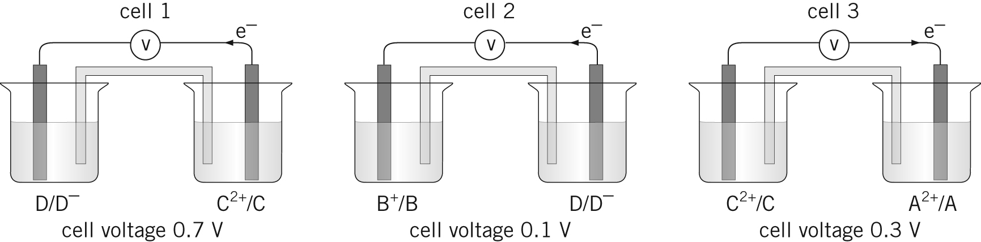
cell potential
cell potential
cell potential

